15 Setting up the Web site on Git Hub

START HERE

# To upload an entire site

Important if you want to move your entire site, you cannot and must not do this from the Github website. It must be moved from the Github desktop app to the Github website from the top button, and it will create the site for you on the Github website.

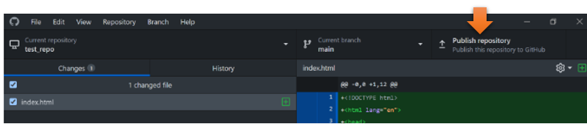

# The Github Desktop app

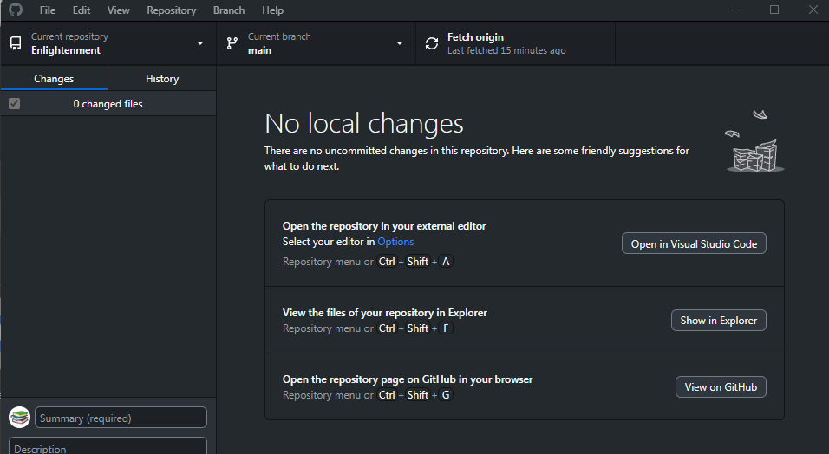

# To Upload an entire site initially

## You must be in Github desktop app.

Do not try to start an entire site upload from the github website, or from Visual Studio. It cannot be done

You can only push an entire site with all of its folders through the Github desktop app



You want to add an existing repository. All this means is that you have already created your website, like we did in this tutorial series, and now you want to push it onto the Github Servers.

Click on this Add button to add the website that we created

## 

Browse to where you site is located inside of Xampp

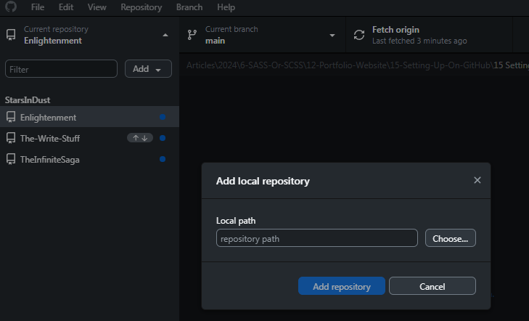

## 

You may have to sign in to github again. Yes this might take forever to reach you.

File- options – sign in continue with browser

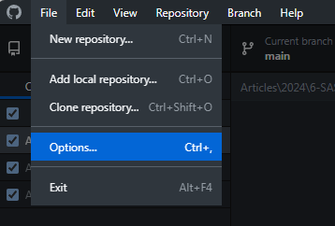

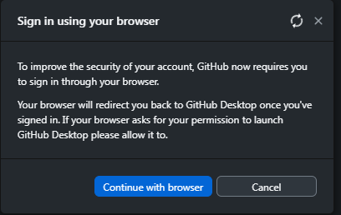

Now you want to Publish the Repository that you selected by hitting this button here

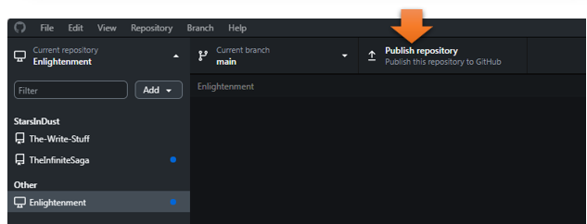

## Go to Your Visual Studio Code.

Make sure that your website folder is open in Visual Studio Code.

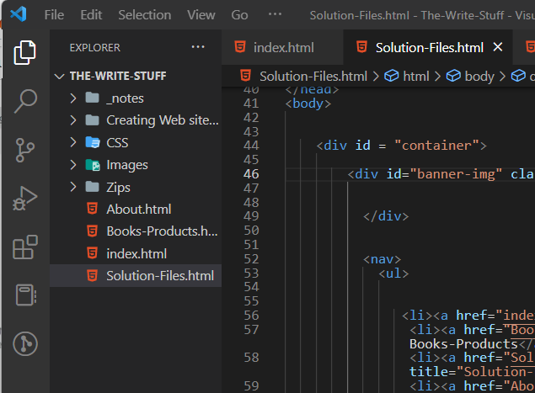

Now from the panel on the left, you want to click on this icon

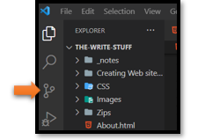

Now you want to initialize Repository

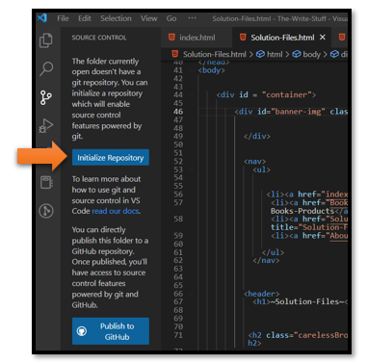

You want to write something in this message box. I wrote First Commit

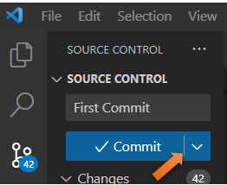

Click on this drop-down button here and choose to Push and Commit

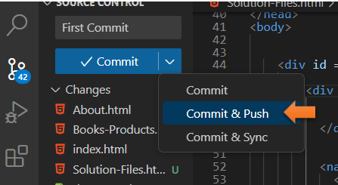

Do notice that everything turned into a lime green mode



Anyways, push the **Commit & Push** option

You will get this message, and you want to click the **YES** button for this.

## Add Your Remote

And you will get this message saying that you do not have a Remote. Click on that Blue button **Add Remote**

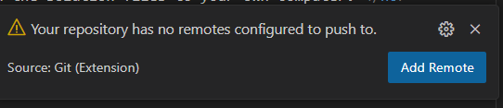

This is where you want to paste that URL that you copied from the Website

<https://github.com/Your> Name/Your Site Name press **ENTER**

You paste it in at the top of the page

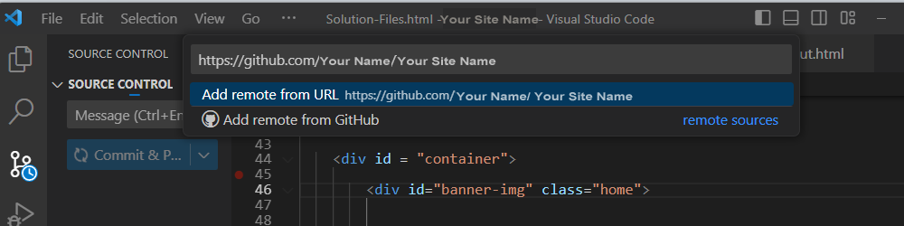

Next it will ask for the Remote Name, just give it the name of your site

Remember to hit **ENTER** so that it will Commit

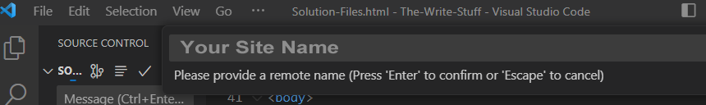

Now in the Source Control icon, you want to click on Publish Branch. This will push your site to Git Hub

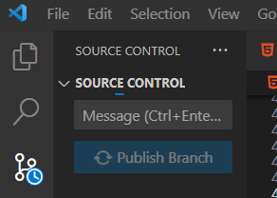

Click on the Green Authorize button

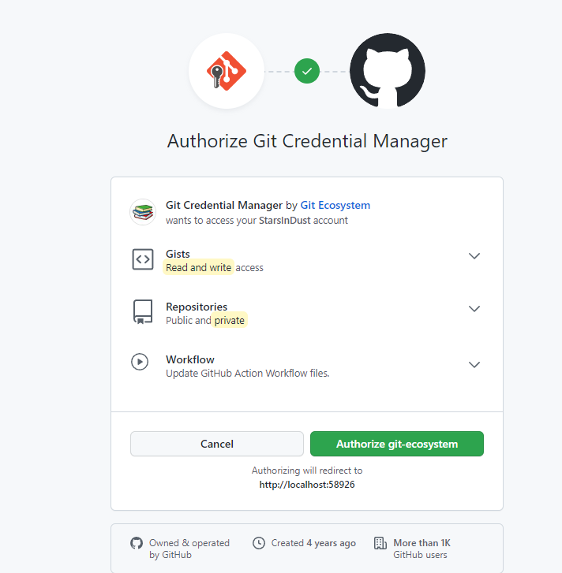

# Now fill in the password or even the user name if need be

**UserName:** **Your User Name**

**Password: Your Password**

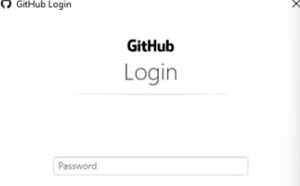



Now just go to your Site URL to see your files inside of github

https://github.com/Your Name/Your Site Name

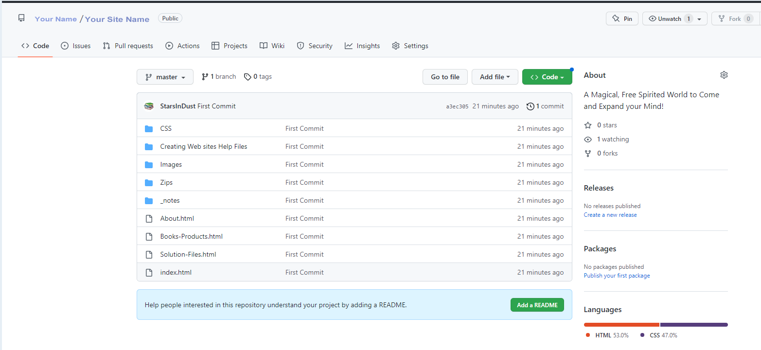

Now you want to Click on the settings icon at the top of the page

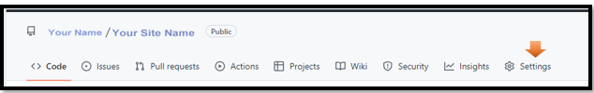

Now go to the left side of the page and click on Pages

# Change site from Private to Public

Top left corner hamburger menu, chose your site

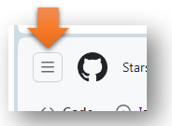

# START HERE



Go to Settings

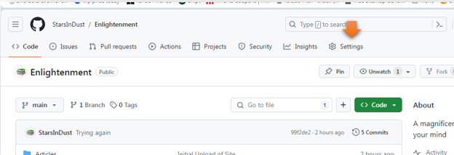

Scroll to bottom of page to danger zone

You want danger zone- Change visibility – public

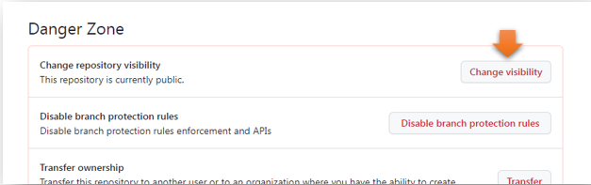

# Enable Github pages

Top left corner hamburger menu, chose your site





Go to Settings



Left side panel inside of Settings, you will find Pages

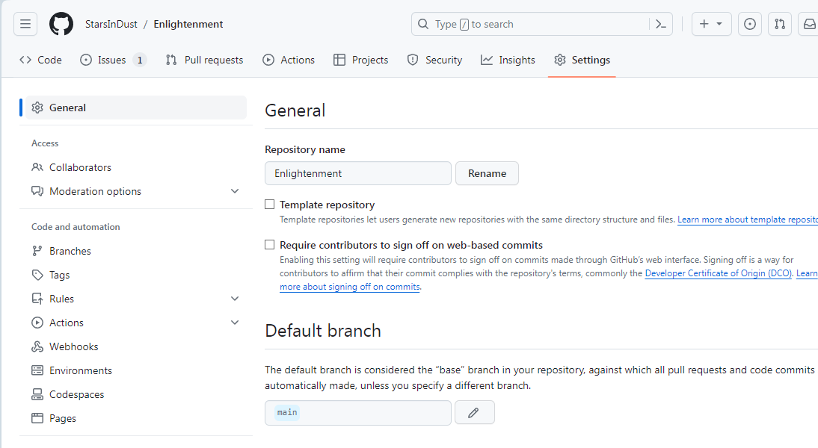

You want to select main from the drop down here

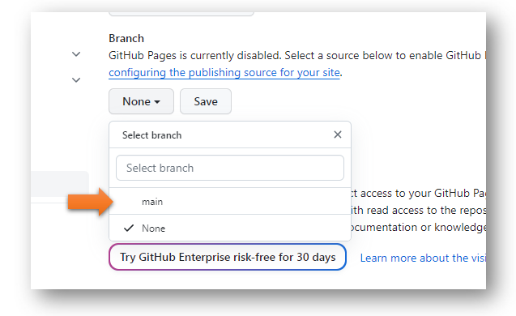

Now the setting should look like this SAVE the settings

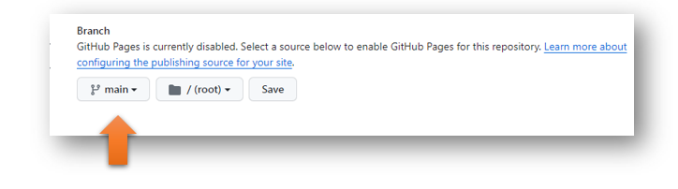

Now at the top of the page you should have a link to view your live site

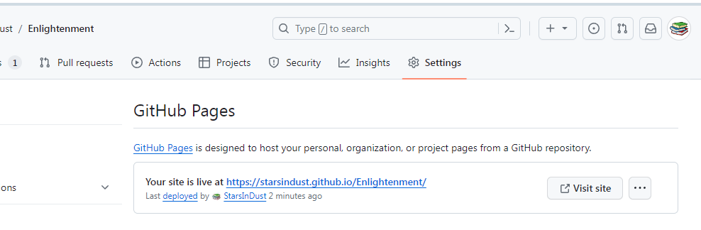

<https://starsindust.github.io/Enlightenment/index.html>

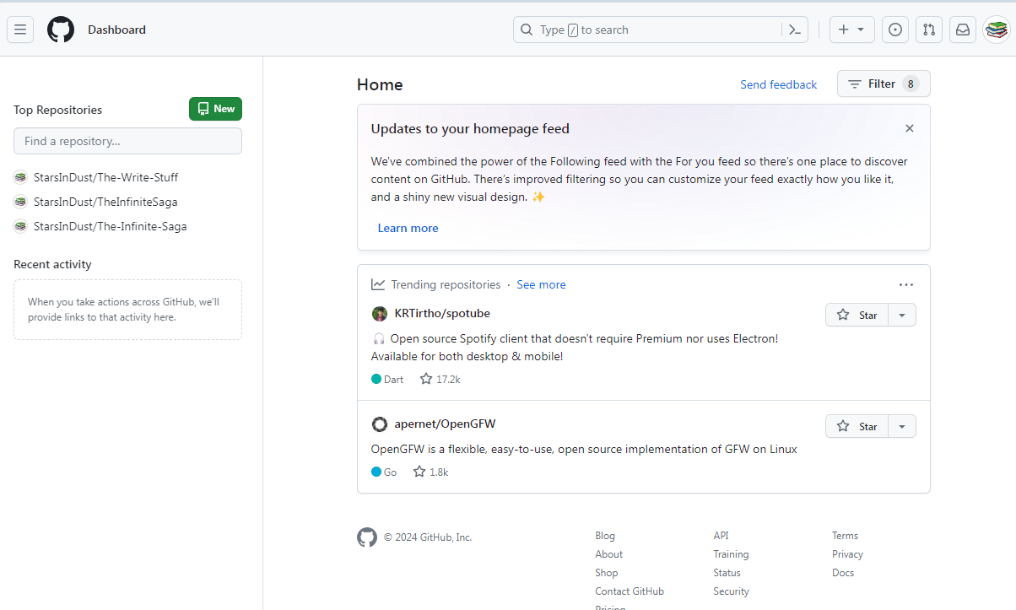

Notice that in 2024, you are able to easily create a new Repository or website, just by going to the left panel in the home page.

# To build your entire site from get-go on Github

This is probably not what you will want to do, you will probably want to upload a site that you already started on your own computer. Go to the top of the page to upload an entire site.

Click on this green button at the top that says **New**

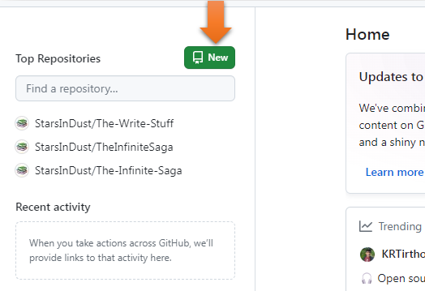

**Name** your site,Or you can import a repository from another URL like GoDaddy

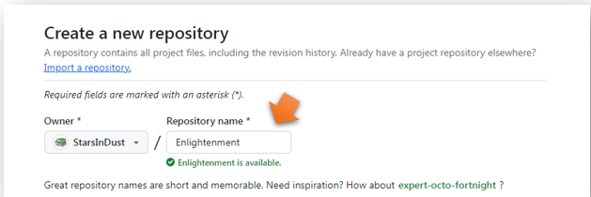

Write a **Description** for your Site

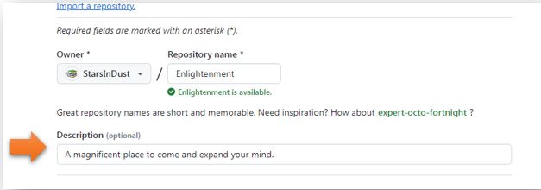

Yes, you want it Public

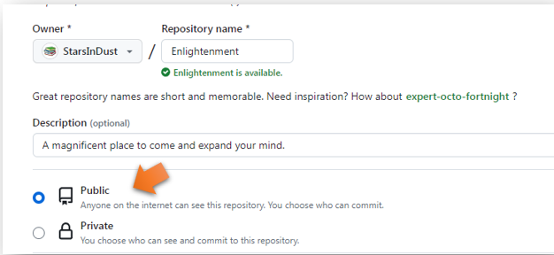

Now scroll to the bottom and create the Repository

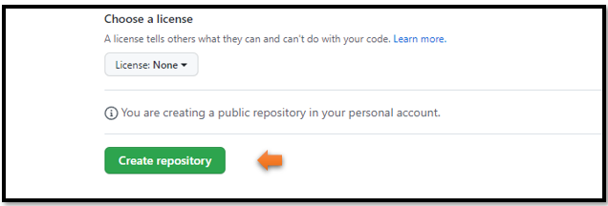

Ok, this page is full of gobblety gook, but what you want to do is to jump to the top of this page **and copy the URL** from there. You need to copy this address from the Heading do not copy from inside the webpage, if it has that git after it, it is wrong

https://github.com/StarsInDust/The-Write-Stuff



You will see that it automatically will provide you with a secure site. GoDaddy never gave us this for free.

Remember, the code you need is in the heading of site, and not one provided inside of the webpage.

<https://github.com/StarsInDust/Enlightenment>



Remember to do the password thing-ee, to do the private to public thing-y and to turn on your pages

# Set Repository Once and Done

You will find that once the repository is set to one specific folder, it will still stay on that repository and you will be able to upload your site to it, forever. Or until you change the location of the folder on your machine. If you ever change the location of that folder on your machine then you will have to reset up the repository again and have it point to that site.

You can check to see if your folder is still pointing to the correct web site, by going to Visual Studio code, and opening the dropdown for repositories.

In Visual Studio, open the folder to the website that you want to check. File> Open Folder

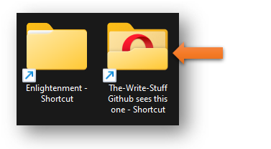

Now from the panel on the left, you want to click on this icon



From there open up the drop down that says Repositories. I have been working for a year in my Enlightenment and other folders, but when I reopen the folder in Visual Studio, I can still see that it is pointing to the correct repository and I will be able to upload new files to this site, without needing to do any extra finagling.

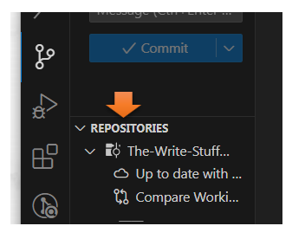

Now if you have a folder that is not pointing to any repository, it will let you know as soon as you open this icon on the left. This is the folder for my book, and it is not connected to a website. Nor does it need to be

